|  |
| --- |
| Piyush Khushlani | 15ME30057 |

|  |
| --- |
| [11th February, 2018] |
| Assignment 2B |

# Description

## Aim is to develop an interactive tool for straightening the panels, so that all of them lie on the plane of the middle panel. The tool should be able to copy and stitch the images of panels to make them a seamless continuous painting.

At first, 4 corner points on the image are selected in generalized fashion which are then transformed to flat painting from the segmented image in rectangular manner.

The three rectangular patterns are then joined one after another after resizing their height to the mean of the three part image heights respectively.

# Results

Image 1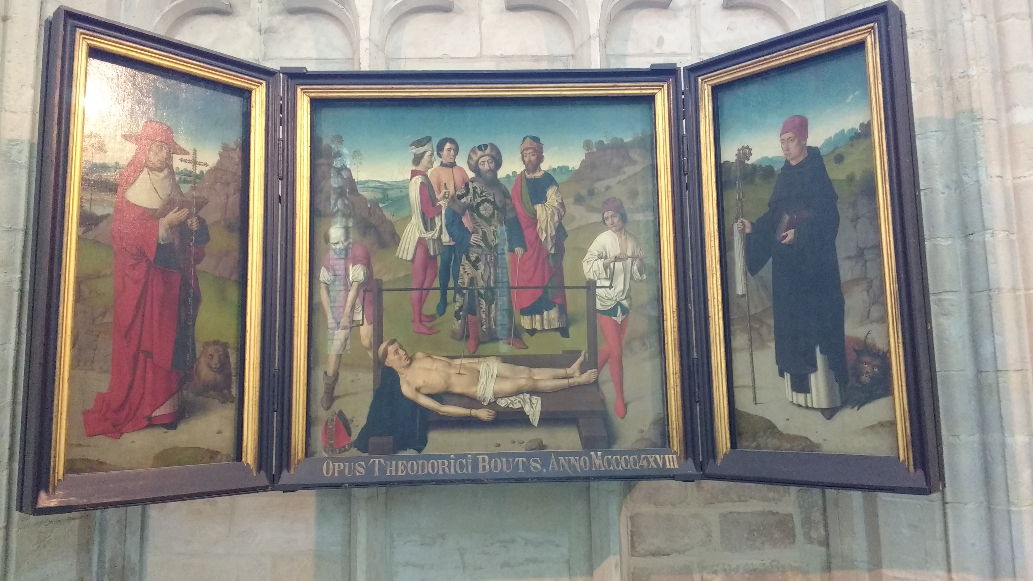

Seamless Painting 1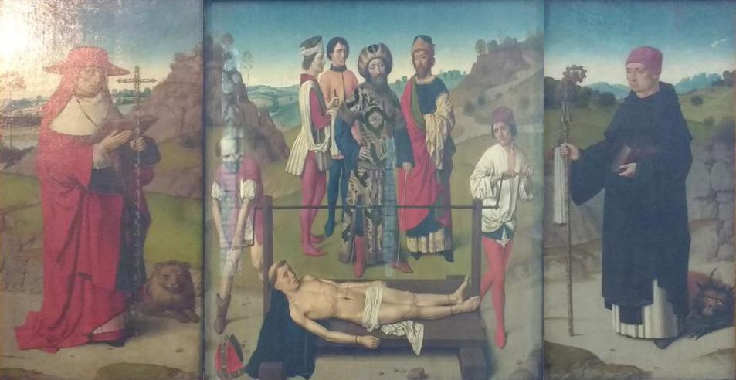

Image 2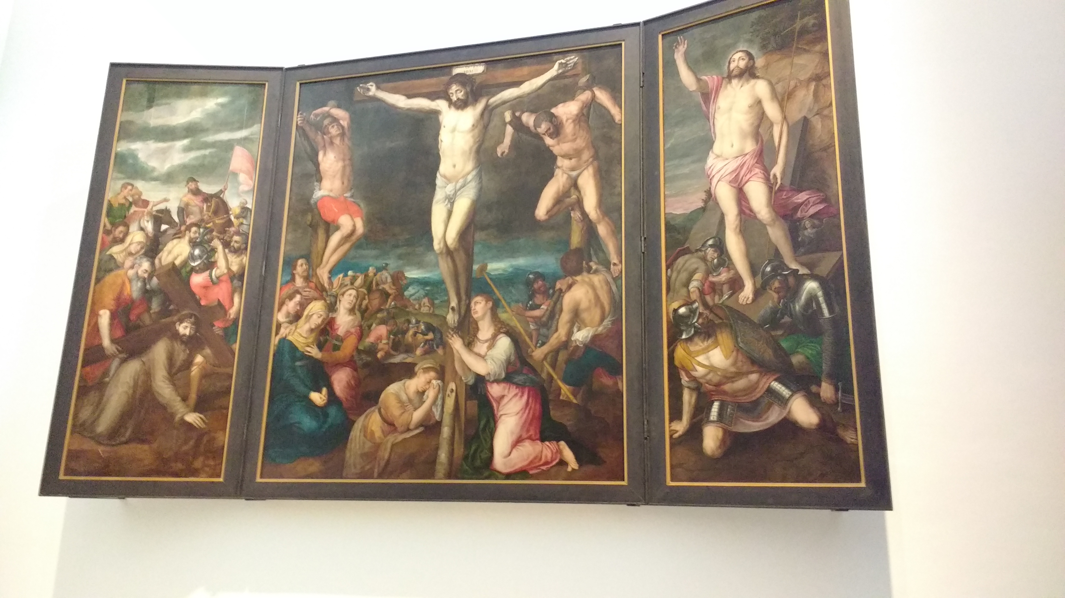

Seamless Painting 2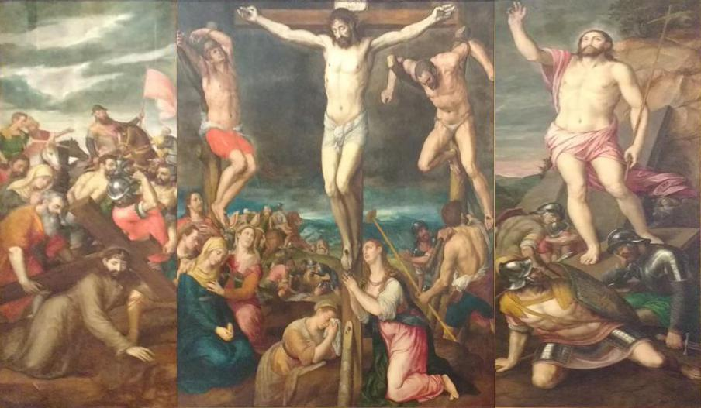

Image 3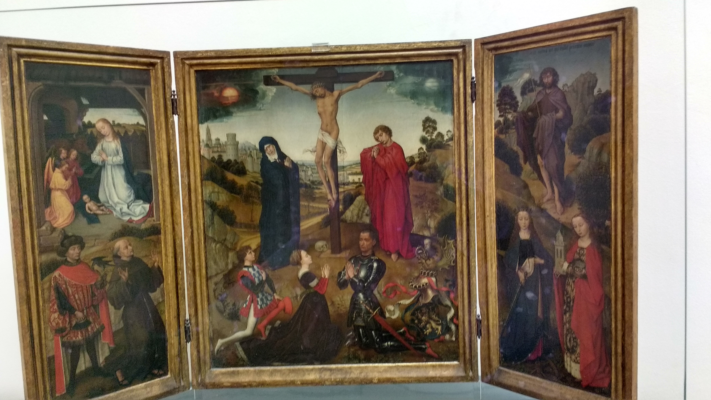

Seamless Painting 3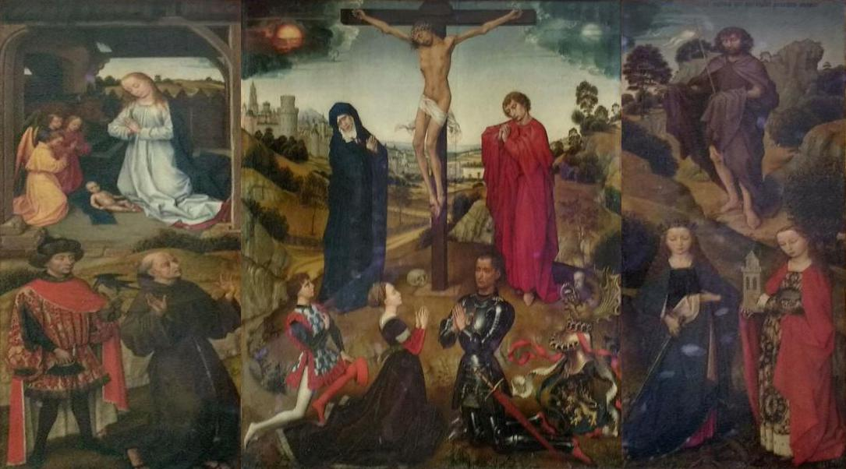

Image 4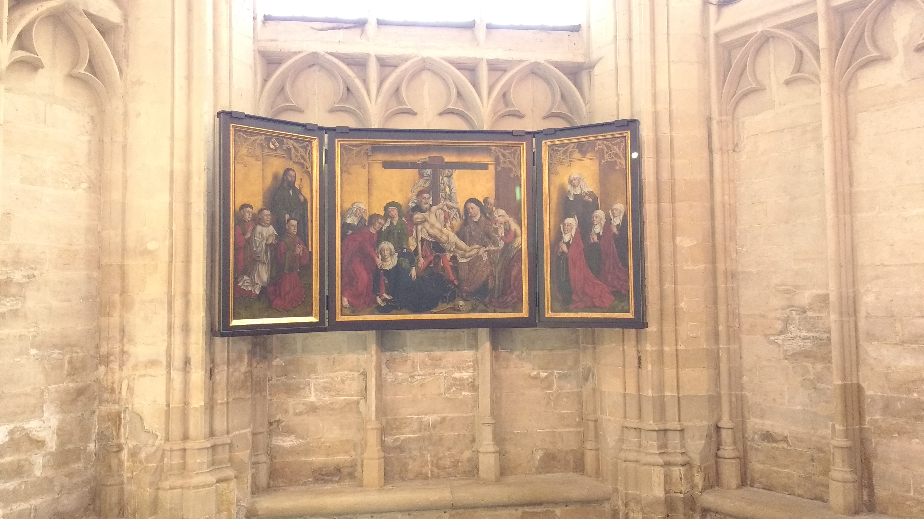

Seamless Painting 4